**BrowserMonkey**



**Testing**

v 0.5

**Software House One**

**Version History**

Document name: QA Team/scratch/Testing.docx

Document version: 0.5

Document author: Paul Calcraft 2009/05/30

Document author: Elpida Kyriakou 2009/06/02

Document author: Ioanna Kyprianou 2009/06/03  
Document author: Irene Schiza 2009/06/05

Document author: Sohani Amiruzzaman 2009/06/06

Document auditor: Ioanna Kyprianou [not yet audited]

Document auditor: Daniel Cooper [not yet audited]

Document auditor: Paul Calcraft [not yet audited]

Document auditor: Sohani Amiruzzaman [not yet audited]

**Table of Contents**

1 Requirement 1 – Basic Renderer 5

2 Requirement 2 – Logging 5

3 Requirement 3 – Conformance 5

3.1 Overview 5

3.2 Invalid tag format 5

3.3 Empty tags 6

3.4 Unrecognised tags 6

3.5 Recognised non-implemented tags 6

3.6 General structure tags 6

3.7 Recognised supported tags 8

3.8 Font tag attributes 9

3.9 Nesting and Order 10

3.10 Content Model 11

4 Requirement 4 – Tags 12

4.1 Blank lines 12

4.2 Heading 13

4.3 Paragraph 14

4.4 Unordered List 15

4.5 Ordered List 16

4.6 Definition List 17

4.7 Blockquote 18

4.8 Centred Text 19

4.9 Pre-formatted Text 20

4.10 Horizontal Rule 21

4.11 Italics 22

4.12 Bold 23

4.13 Teletype 24

4.14 Underline 25

4.15 Font 26

5 Requirements 5 – Tables 27

6 Requirement 6 – Links 28

7 Requirement 7 – Search 30

4.ACC7-0010 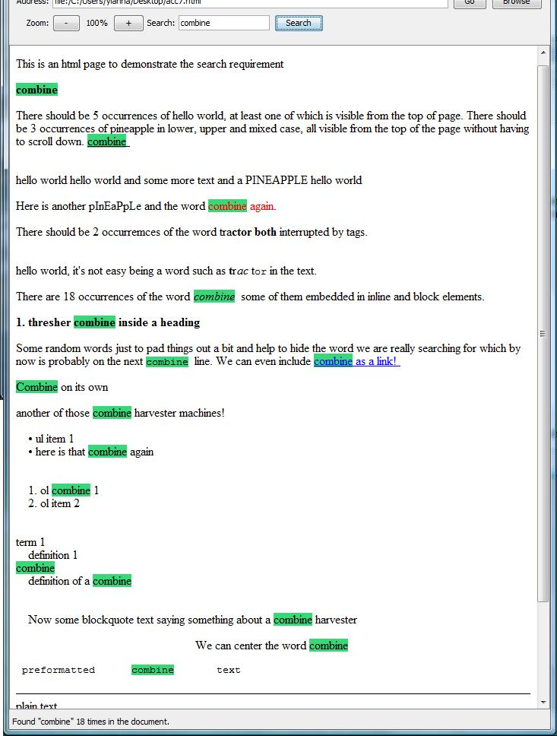 33

8 Requirement 8 – Zoom 34

# Requirement 1 – Basic Renderer

Etc.

# Requirement 2 – Logging

Etc.

# Requirement 3 – Conformance

## Overview

## Invalid tag format

Test passed

|  |  |  |  |  |
| --- | --- | --- | --- | --- |
| **Tests Id** | **Tested by** | **Most Recent Test** | **Pass/Fail** | **Details** |
| acc3-2-0001 | Ioanna Kyprianou | 05/06/2009 | Pass |  |
| acc3-2-0002 | Ioanna Kyprianou | 05/06/2009 | Pass |  |
| acc3-2-0003 | Ioanna Kyprianou | 05/06/2009 | Pass |  |

Screenshot

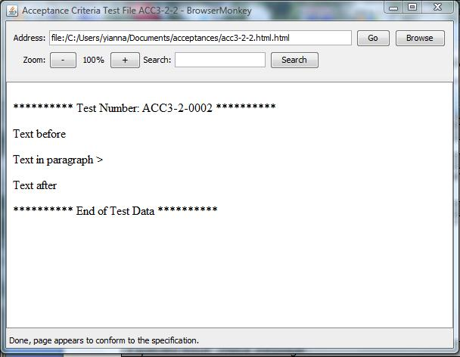

Log file:

05-Jun-2009 18:49:52 browsermonkey.utility.BrowserMonkeyLogger status

INFO: Loading file:/C:/Users/yianna/Documents/acceptances/acc3-2-2.html.html

05-Jun-2009 18:49:52 browsermonkey.utility.BrowserMonkeyLogger status

INFO: Loading file:/C:/Users/yianna/Documents/acceptances/acc3-2-2.html.html

05-Jun-2009 18:49:52 browsermonkey.utility.BrowserMonkeyLogger status

INFO: Done, page appears to conform to the specification.

## Empty tags

Test passed

|  |  |  |  |  |
| --- | --- | --- | --- | --- |
| **Tests Id** | **Tested by** | **Most Recent Test** | **Pass/Fail** | **Details** |
| acc3-2-0001 | Ioanna Kyprianou | 05/06/2009 | Pass |  |

## Unrecognised tags

Test passed

|  |  |  |  |  |
| --- | --- | --- | --- | --- |
| **Tests Id** | **Tested by** | **Most Recent Test** | **Pass/Fail** | **Details** |
| acc3-4-0001 | Ioanna Kyprianou | 05/06/2009 | Fail |  |

## Recognised non-implemented tags

|  |  |  |  |  |
| --- | --- | --- | --- | --- |
| **Tests Id** | **Tested by** | **Most Recent Test** | **Pass/Fail** | **Details** |
| acc3-5-0001 | Ioanna Kyprianou | 05/06/2009 | Fail |  |

## General structure tags

Test passed

|  |  |  |  |  |
| --- | --- | --- | --- | --- |
| **Tests Id** | **Tested by** | **Most Recent Test** | **Pass/Fail** | **Details** |
| acc3-6-0001 | Ioanna Kyprianou | 05/06/2009 | Pass |  |
| acc3-6-0002 | Ioanna Kyprianou | 05/06/2009 | Pass |  |
| acc3-6-0003 | Ioanna Kyprianou | 05/06/2009 | Pass |  |
| acc3-6-0004 | Ioanna Kyprianou | 05/06/2009 | Pass |  |
| acc3-6-0005 | Ioanna Kyprianou | 05/06/2009 | Pass |  |
| acc3-6-0006 | Ioanna Kyprianou | 05/06/2009 | Pass |  |
| acc3-6-0007 | Ioanna Kyprianou | 05/06/2009 | Pass |  |
| acc3-6-0008 | Ioanna Kyprianou | 05/06/2009 | Pass |  |
| acc3-6-0009 | Ioanna Kyprianou | 05/06/2009 | Pass |  |
| acc3-6-00010 | Ioanna Kyprianou | 05/06/2009 | Pass |  |
| acc3-6-00011 | Ioanna Kyprianou | 05/06/2009 | Pass |  |

Screen shot

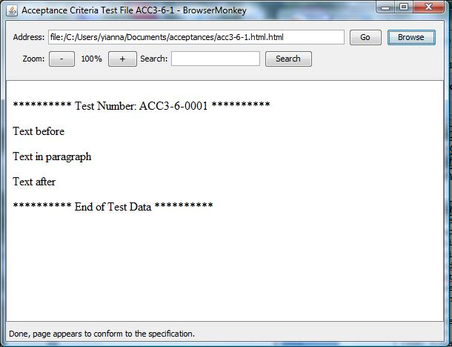

Log File

05-Jun-2009 19:03:09 browsermonkey.utility.BrowserMonkeyLogger status

INFO: Loading file:/C:/Users/yianna/Documents/acceptances/acc3-6-1.html.html

05-Jun-2009 19:03:09 browsermonkey.utility.BrowserMonkeyLogger status

INFO: Loading file:/C:/Users/yianna/Documents/acceptances/acc3-6-1.html.html

05-Jun-2009 19:03:09 browsermonkey.utility.BrowserMonkeyLogger status

INFO: Done, page appears to conform to the specification.

## Recognised supported tags

|  |  |  |  |  |
| --- | --- | --- | --- | --- |
| **Tests Id** | **Tested by** | **Most Recent Test** | **Pass/Fail** | **Details** |
| acc3-7-0001 | Ioanna Kyprianou | 05/06/2009 | Pass |  |
| acc3-7-0002 | Ioanna Kyprianou | 05/06/2009 | Pass |  |
| acc3-7-0003 | Ioanna Kyprianou | 05/06/2009 | Fail |  |
| acc3-7-0004 | Ioanna Kyprianou | 05/06/2009 | Pass |  |
| acc3-7-0005 | Ioanna Kyprianou | 05/06/2009 | Fail |  |
| acc3-7-0006 | Ioanna Kyprianou | 05/06/2009 | Fail |  |
| acc3-7-0007 | Ioanna Kyprianou | 05/06/2009 | Fail |  |
| acc3-7-0008 | Ioanna Kyprianou | 05/06/2009 | Pass |  |
| acc3-7-0009 | Ioanna Kyprianou | 05/06/2009 | Pass |  |

Screen shot

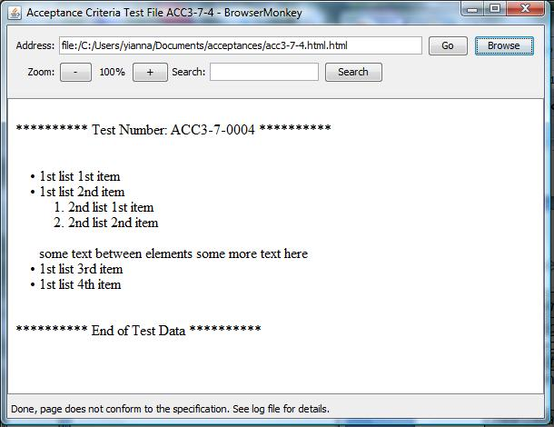

Log File

INFO: Loading file:/C:/Users/yianna/Documents/acceptances/acc3-7-4.html.html

05-Jun-2009 19:27:55 browsermonkey.utility.BrowserMonkeyLogger status

INFO: Loading file:/C:/Users/yianna/Documents/acceptances/acc3-7-4.html.html

05-Jun-2009 19:27:55 browsermonkey.utility.BrowserMonkeyLogger conformance

WARNING: List Error: shorthand list notation - closing <li>.

05-Jun-2009 19:27:55 browsermonkey.utility.BrowserMonkeyLogger conformance

WARNING: List Error: shorthand list notation - closing <li>.

05-Jun-2009 19:27:55 browsermonkey.utility.BrowserMonkeyLogger status

INFO: Done, page does not conform to the specification. See log file for details.

05-Jun-2009 19:27:55 browsermonkey.utility.BrowserMonkeyLogger status

INFO: Done, page does not conform to the specification. See log file for details.

05-Jun-2009 19:29:14 browsermonkey.utility.BrowserMonkeyLogger status

## Font tag attributes

Test passed.

|  |  |  |  |  |
| --- | --- | --- | --- | --- |
| **Tests Id** | **Tested by** | **Most Recent Test** | **Pass/Fail** | **Details** |
| acc3-8-0001 | Irene Schiza | 05/06/2009 | Pass |  |
| acc3-8-0002 | Irene Schiza | 05/06/2009 | Pass |  |
| acc3-8-0003 | Irene Schiza | 05/06/2009 | Pass |  |
| acc3-8-0004 | Irene Schiza | 05/06/2009 | Fail |  |
| acc3-8-0005 | Irene Schiza | 05/06/2009 | Pass |  |
| acc3-8-0006 | Irene Schiza | 05/06/2009 | Pass |  |
| acc3-8-0007 | Irene Schiza | 05/06/2009 | Pass |  |
| acc3-8-0008 | Irene Schiza | 05/06/2009 | Fail |  |
| acc3-8-0009 | Irene Schiza | 05/06/2009 | Fail |  |
| acc3-8-0010 | Irene Schiza | 05/06/2009 | Pass |  |
| acc3-8-0011 | Irene Schiza | 05/06/2009 | Fail |  |
| acc3-8-0012 | Irene Schiza | 05/06/2009 | Pass |  |

***Screenshot of acc3-8-0001.html***

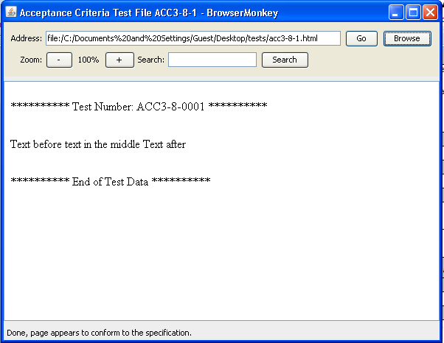

***Expected result: Log message***

INFO: Loading file:/C:/Documents%20and%20Settings/Guest/Desktop/tests/acc3-8-1.html

05-Jun-2009 21:05:21 browsermonkey.utility.BrowserMonkeyLogger status

INFO: Done, page appears to conform to the specification.

## Nesting and Order

Test passed.

|  |  |  |  |  |
| --- | --- | --- | --- | --- |
| **Tests Id** | **Tested by** | **Most Recent Test** | **Pass/Fail** | **Details** |
| acc3-9-0001 | Irene Schiza | 05/06/2009 | Pass |  |
| acc3-9-0002 | Irene Schiza | 05/06/2009 | Fail |  |
| acc3-9-0003 | Irene Schiza | 05/06/2009 | Pass |  |
| acc3-9-0004 | Irene Schiza | 05/06/2009 | Fail |  |
| acc3-9-0005 | Irene Schiza | 05/06/2009 | Fail |  |
| acc3-9-0006 | Irene Schiza | 05/06/2009 | Fail |  |

***Screenshot***

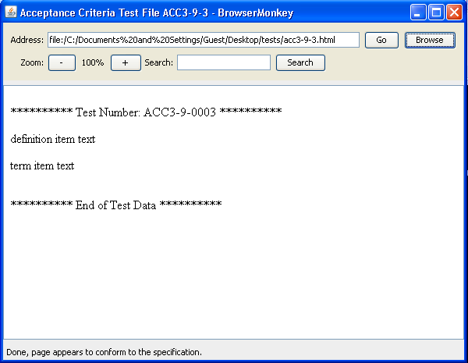

***Expected result: Log message***

INFO: Loading file:/C:/Documents%20and%20Settings/Guest/Desktop/tests/acc3-9-3.html

05-Jun-2009 21:34:01 browsermonkey.utility.BrowserMonkeyLogger status

INFO: Done, page appears to conform to the specification.

## Content Model

Test passed.

|  |  |  |  |  |
| --- | --- | --- | --- | --- |
| **Tests Id** | **Tested by** | **Most Recent Test** | **Pass/Fail** | **Details** |
| acc3-10-0001 | Irene Schiza | 05/06/2009 | Fail |  |

# Requirement 4 – Tags

## Blank lines

Test passed.

|  |  |  |  |  |
| --- | --- | --- | --- | --- |
| test id | **Tested by** | **Most Recent Test** | **Pass**  **/Fail** | **Details** |
| acc4-1-0001 | Sohani Amiruzzaman | 05/06/2009 | pass |  |

Screenshot

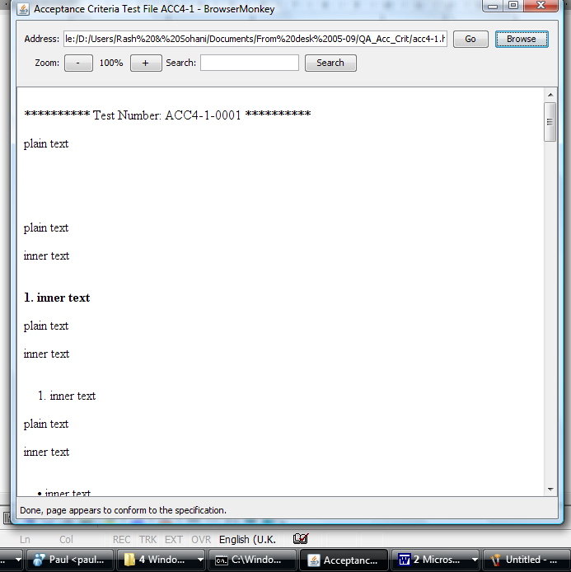

## Heading

Test passed.

|  |  |  |  |  |
| --- | --- | --- | --- | --- |
| **Test id** | **Tested by** | **Most recent test** | **Pass/fail** | **Details** |
| acc4-2-0001 | Sohani Amiruzzaman | 05/06/2009 | pass |  |
| acc4-2-0002 | Sohani Amiruzzaman | 05/06/2009 | pass |  |
| acc4-2-0003 | Sohani Amiruzzaman | 05/06/2009 | pass |  |
| acc4-2-0004 | Sohani Amiruzzaman | 05/06/2009 | pass |  |
| acc4-2-0005 | Sohani Amiruzzaman | 05/06/2009 | pass |  |
| acc4-2-0006 | Sohani Amiruzzaman | 05/06/2009 | pass |  |
| acc4-2-0007 | Sohani Amiruzzaman | 05/06/2009 | pass |  |
| acc4-2-0008 | Sohani Amiruzzaman | 05/06/2009 | pass |  |

Screenshot

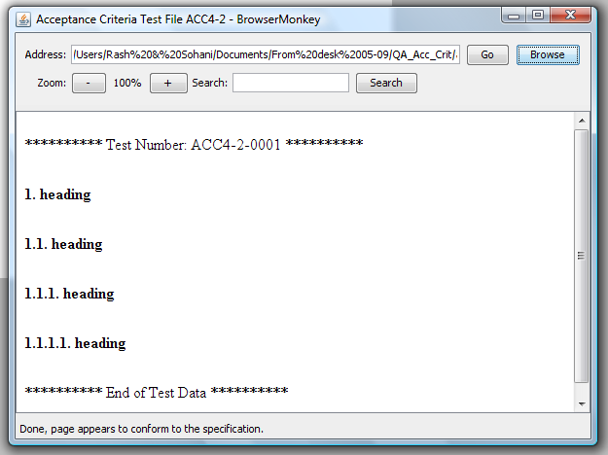

## Paragraph

Test passed.

|  |  |  |  |  |
| --- | --- | --- | --- | --- |
| **Test id** | **Tested by** | **Most recent test** | **Pass/fail** | **Details** |
| acc4-3-0001 | Sohani Amiruzzaman | 05/06/2009 | pass |  |
| acc4-3-0002 | Sohani Amiruzzaman | 05/06/2009 | pass |  |
| acc4-3-0003 | Sohani Amiruzzaman | 05/06/2009 | pass |  |

Screenshot

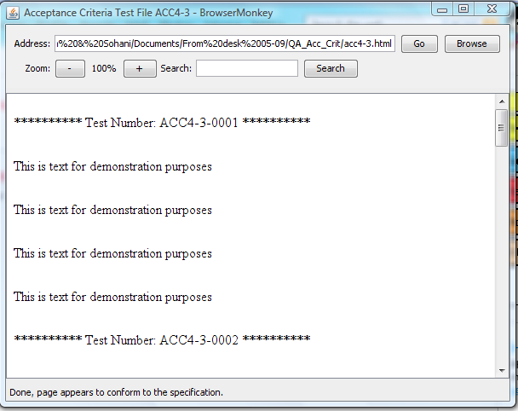

## Unordered List

Test passed.

|  |  |  |  |  |
| --- | --- | --- | --- | --- |
| **Test id** | **Tested by** | **Most recent test** | **Pass/fail** | **Details** |
| acc4-4-0002 | Sohani Amiruzzaman | 05/06/2009 | pass |  |
| acc4-4-0003 | Sohani Amiruzzaman | 05/06/2009 | pass |  |
| acc4-4-0004 | Sohani Amiruzzaman | 05/06/2009 | pass |  |
| acc4-4-0005 | Sohani Amiruzzaman | 05/06/2009 | pass |  |
| acc4-4-0006 | Sohani Amiruzzaman | 05/06/2009 | pass |  |
| acc4-4-0007 | Sohani Amiruzzaman | 05/06/2009 | pass |  |
| acc4-4-0008 | Sohani Amiruzzaman | 05/06/2009 | pass |  |
| acc4-4-0009 | Sohani Amiruzzaman | 05/06/2009 | pass |  |
| acc4-4-0010 | Sohani Amiruzzaman | 05/06/2009 | pass |  |

Screenshot

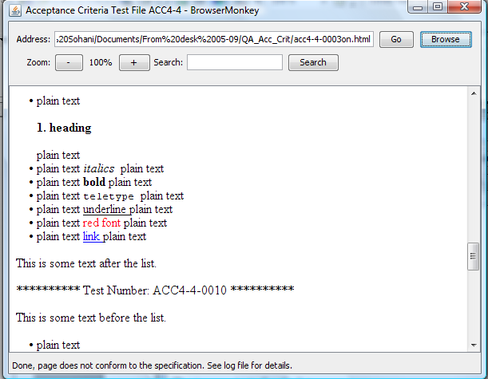

## Ordered List

Test passed.

|  |  |  |  |  |
| --- | --- | --- | --- | --- |
| **Test id** | **Tested by** | **Most recent test** | **Pass/fail** | **Details** |
| acc4-5-0001 | Sohani Amiruzzaman | 05/06/2009 | pass |  |
| acc4-5-0002 | Sohani Amiruzzaman | 05/06/2009 | pass |  |
| acc4-5-0003 | Sohani Amiruzzaman | 05/06/2009 | pass |  |
| acc4-5-0004 | Sohani Amiruzzaman | 05/06/2009 | pass |  |
| acc4-5-0005 | Sohani Amiruzzaman | 05/06/2009 | pass |  |
| acc4-5-0006 | Sohani Amiruzzaman | 05/06/2009 | pass |  |
| acc4-5-0007 | Sohani Amiruzzaman | 05/06/2009 | pass |  |
| acc4-5-0008 | Sohani Amiruzzaman | 05/06/2009 | pass |  |
| acc4-5-0009 | Sohani Amiruzzaman | 05/06/2009 | pass |  |
| acc4-5-0010 | Sohani Amiruzzaman | 05/06/2009 | pass |  |

Screenshot

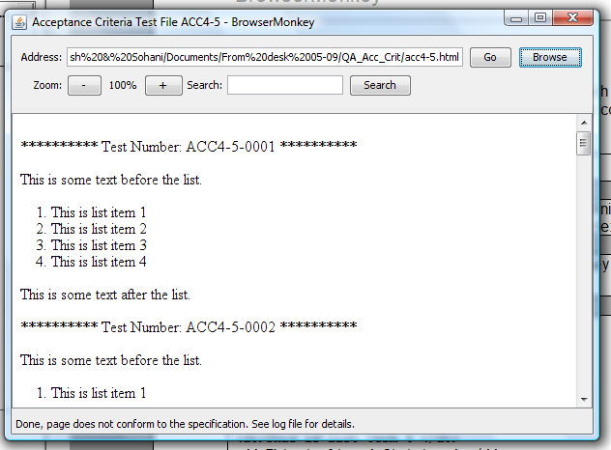

## Definition List

Test passed.

|  |  |  |  |  |
| --- | --- | --- | --- | --- |
| **Test id** | **Tested by** | **Most recent test** | **Pass/fail** | **Details** |
| acc4-6-0001 | Sohani Amiruzzaman | 05/06/2009 | pass |  |
| acc4-6-0002 | Sohani Amiruzzaman | 05/06/2009 | pass |  |
| acc4-6-0003 | Sohani Amiruzzaman | 05/06/2009 | pass |  |
| acc4-6-0004 | Sohani Amiruzzaman | 05/06/2009 | pass |  |
| acc4-6-0005 | Sohani Amiruzzaman | 05/06/2009 | pass |  |
| acc4-6-0006 | Sohani Amiruzzaman | 05/06/2009 | pass |  |
| acc4-6-0007 | Sohani Amiruzzaman | 05/06/2009 | pass |  |
| acc4-6-0008 | Sohani Amiruzzaman | 05/06/2009 | pass |  |
| acc4-6-0009 | Sohani Amiruzzaman | 05/06/2009 | pass |  |
| acc4-6-0010 | Sohani Amiruzzaman | 05/06/2009 | pass |  |
| acc4-6-0011 | Sohani Amiruzzaman | 05/06/2009 | pass |  |

Screenshot

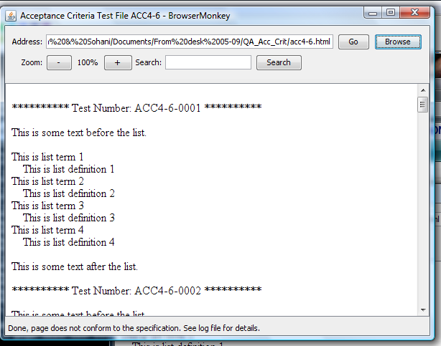

## Blockquote

Test passed.

|  |  |  |  |  |
| --- | --- | --- | --- | --- |
| **Test id** | **Tested by** | **Most recent test** | **Pass/fail** | **Details** |
| acc4-7-0001 | Sohani Amiruzzaman | 05/06/2009 | pass |  |
| acc4-7-0002 | Sohani Amiruzzaman | 05/06/2009 | pass |  |
| acc4-7-0003 | Sohani Amiruzzaman | 05/06/2009 | pass |  |
| acc4-7-0004 | Sohani Amiruzzaman | 05/06/2009 | pass |  |
| acc4-7-0005 | Sohani Amiruzzaman | 05/06/2009 | pass |  |
| acc4-7-0006 | Sohani Amiruzzaman | 05/06/2009 | pass |  |
| acc4-7-0007 | Sohani Amiruzzaman | 05/06/2009 | pass |  |
| acc4-7-0008 | Sohani Amiruzzaman | 05/06/2009 | pass |  |

Screenshot

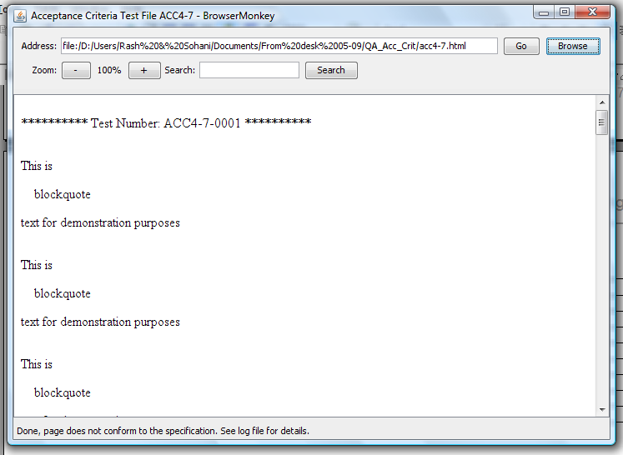

## Centred Text

Test passed.

|  |  |  |  |  |
| --- | --- | --- | --- | --- |
| **Tests Id** | **Tested by** | **Most Recent Test** | **Pass/Fail** | **Details** |
| acc4-8-0001 | Elpida Kyriakou | 05/06/2009 | Pass |  |
| acc4-8-0002 | Elpida Kyriakou | 05/06/2009 | Pass |  |
| acc4-8-0003 | Elpida Kyriakou | 05/06/2009 | Pass |  |
| acc4-8-0004 | Elpida Kyriakou | 05/06/2009 | Pass |  |
| acc4-8-0005 | Elpida Kyriakou | 05/06/2009 | Pass |  |
| acc4-8-0006 | Elpida Kyriakou | 05/06/2009 | Pass |  |
| acc4-8-0007 | Elpida Kyriakou | 05/06/2009 | Pass |  |
| acc4-8-0008 | Elpida Kyriakou | 05/06/2009 | Pass |  |

Screenshot

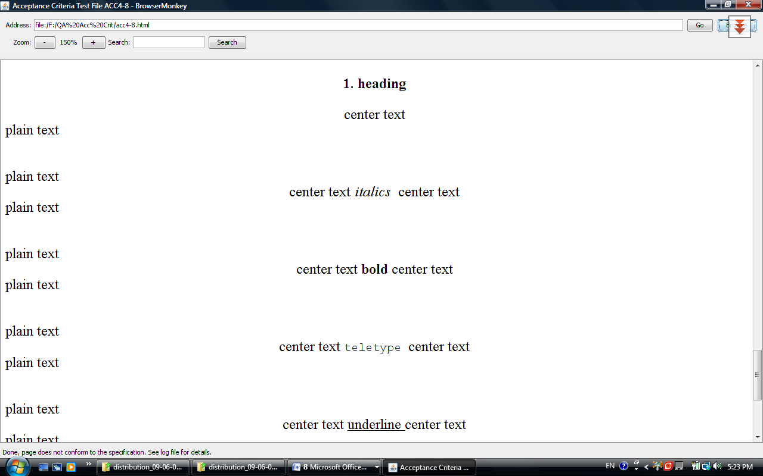

## Pre-formatted Text

Test passed

|  |  |  |  |  |
| --- | --- | --- | --- | --- |
| **Tests Id** | **Tested by** | **Most Recent Test** | **Pass/Fail** | **Details** |
| acc4-9-0001 | Elpida Kyriakou | 05/06/2009 | Pass |  |
| acc4-9-0002 | Elpida Kyriakou | 05/06/2009 | Pass |  |
| acc4-9-0003 | Elpida Kyriakou | 05/06/2009 | Pass |  |
| acc4-9-0004 | Elpida Kyriakou | 05/06/2009 | Pass |  |
| acc4-9-0005 | Elpida Kyriakou | 05/06/2009 | Pass |  |
| acc4-9-0006 | Elpida Kyriakou | 05/06/2009 | Pass |  |
| acc4-9-0007 | Elpida Kyriakou | 05/06/2009 | Pass |  |
| acc4-9-0008 | Elpida Kyriakou | 05/06/2009 | Pass |  |

Screenshot

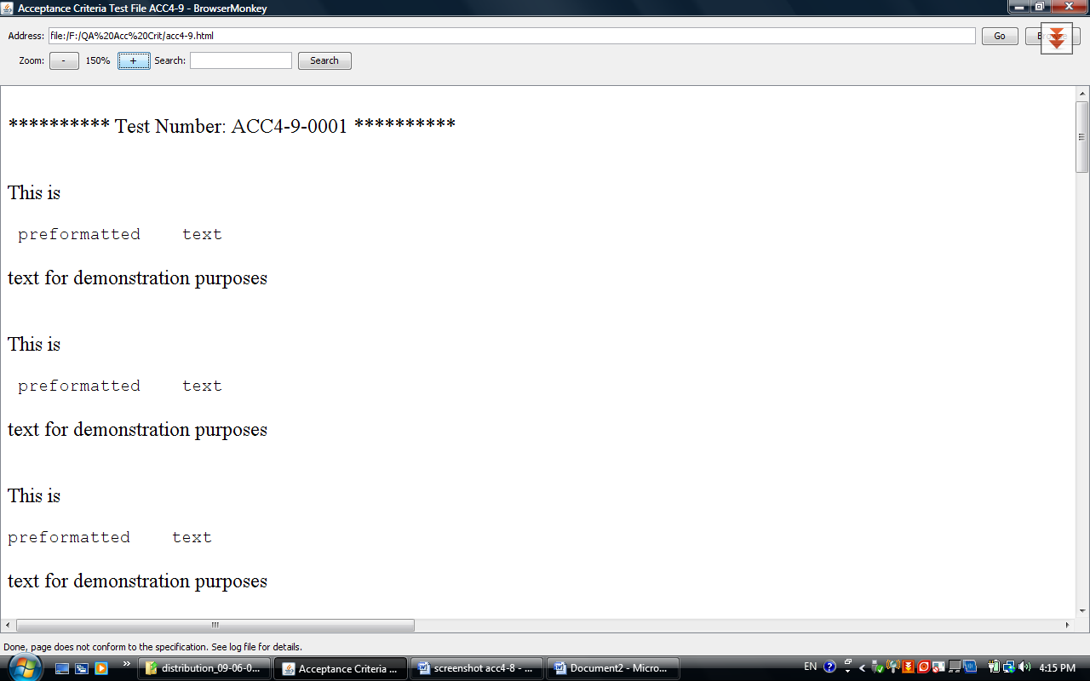

## Horizontal Rule

Test Passed

|  |  |  |  |  |
| --- | --- | --- | --- | --- |
| **Tests Id** | **Tested by** | **Most Recent Test** | **Pass/Fail** | **Details** |
| acc4-10-0001 | Elpida Kyriakou | 05/06/2009 | Pass |  |
| acc4-10-0002 | Elpida Kyriakou | 05/06/2009 | Pass |  |
| acc4-10-0003 | Elpida Kyriakou | 05/06/2009 | Pass |  |
| acc4-10-0004 | Elpida Kyriakou | 05/06/2009 | Pass |  |

Screenshot

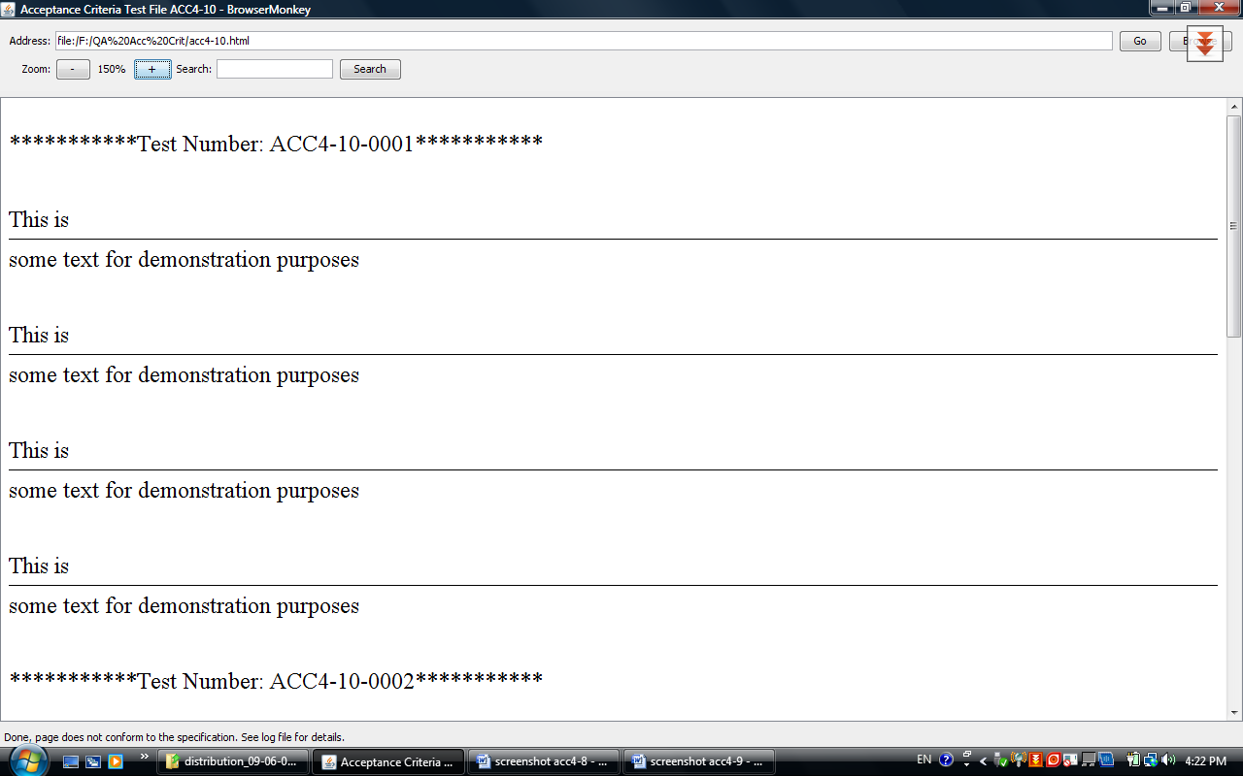

## Italics

Tested passed

|  |  |  |  |  |
| --- | --- | --- | --- | --- |
| **Tests Id** | **Tested by** | **Most Recent Test** | **Pass/Fail** | **Details** |
| acc4-11-0001 | Elpida Kyriakou | 05/06/2009 | Pass |  |
| acc4-11-0002 | Elpida Kyriakou | 05/06/2009 | Pass |  |
| acc4-11-0003 | Elpida Kyriakou | 05/06/2009 | Pass |  |
| acc4-11-0004 | Elpida Kyriakou | 05/06/2009 | Pass |  |
| acc4-11-0005 | Elpida Kyriakou | 05/06/2009 | Pass |  |
| acc4-11-0006 | Elpida Kyriakou | 05/06/2009 | Pass |  |
| acc4-11-0007 | Elpida Kyriakou | 05/06/2009 | Pass |  |
| acc4-11-0008 | Elpida Kyriakou | 05/06/2009 | Pass |  |

Screenshot

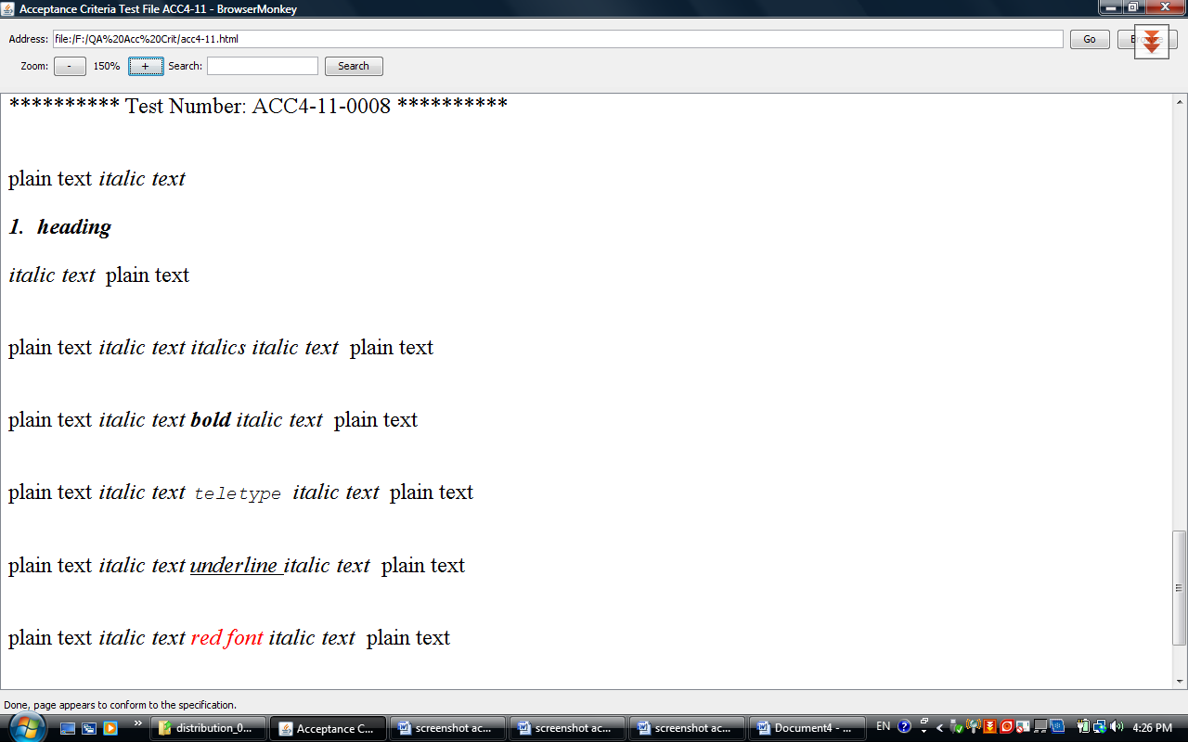

## Bold

Test passed

|  |  |  |  |  |
| --- | --- | --- | --- | --- |
| **Tests Id** | **Tested by** | **Most Recent Test** | **Pass/Fail** | **Details** |
| acc4-12-0001 | Elpida Kyriakou | 05/06/2009 | Pass |  |
| acc4-12-0002 | Elpida Kyriakou | 05/06/2009 | Pass |  |
| acc4-12-0003 | Elpida Kyriakou | 05/06/2009 | Pass |  |
| acc4-12-0004 | Elpida Kyriakou | 05/06/2009 | Pass |  |
| acc4-12-0005 | Elpida Kyriakou | 05/06/2009 | Pass |  |
| acc4-12-0006 | Elpida Kyriakou | 05/06/2009 | Pass |  |
| acc4-12-0007 | Elpida Kyriakou | 05/06/2009 | Pass |  |
| acc4-12-0008 | Elpida Kyriakou | 05/06/2009 | Pass |  |

Screenshot

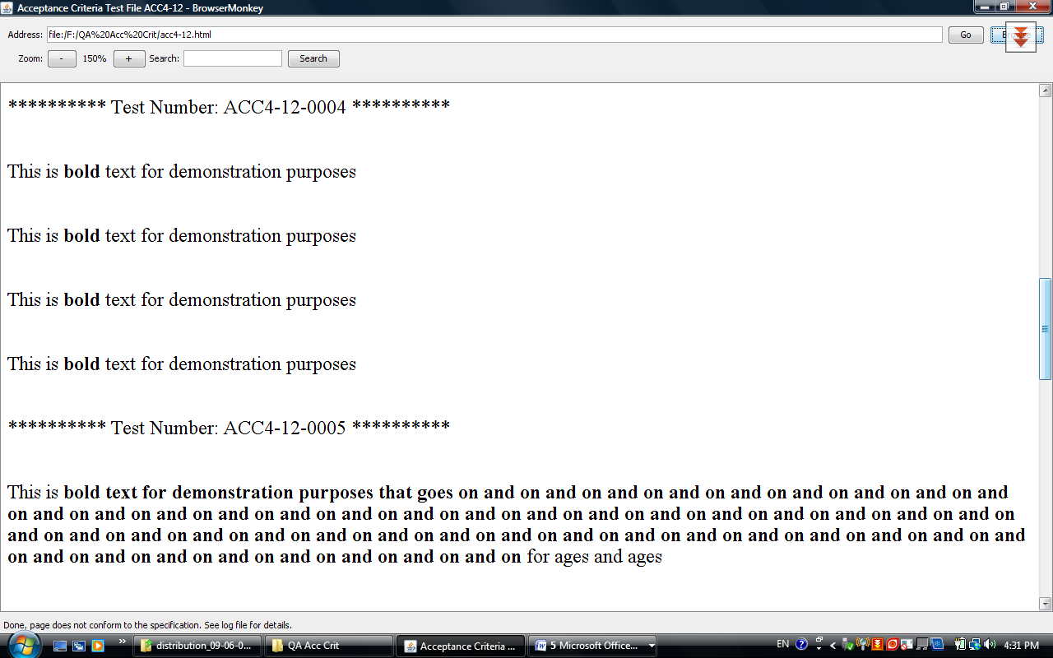

## Teletype

Test Passed

|  |  |  |  |  |
| --- | --- | --- | --- | --- |
| **Tests Id** | **Tested by** | **Most Recent Test** | **Pass/Fail** | **Details** |
| acc4-13-0001 | Elpida Kyriakou | 05/06/2009 | Pass |  |
| acc4-13-0002 | Elpida Kyriakou | 05/06/2009 | Pass |  |
| acc4-13-0003 | Elpida Kyriakou | 05/06/2009 | Pass |  |
| acc4-13-0004 | Elpida Kyriakou | 05/06/2009 | Pass |  |
| acc4-13-0005 | Elpida Kyriakou | 05/06/2009 | Pass |  |
| acc4-13-0006 | Elpida Kyriakou | 05/06/2009 | Pass |  |
| acc4-13-0007 | Elpida Kyriakou | 05/06/2009 | Pass |  |
| acc4-13-0008 | Elpida Kyriakou | 05/06/2009 | Pass |  |

Screenshot

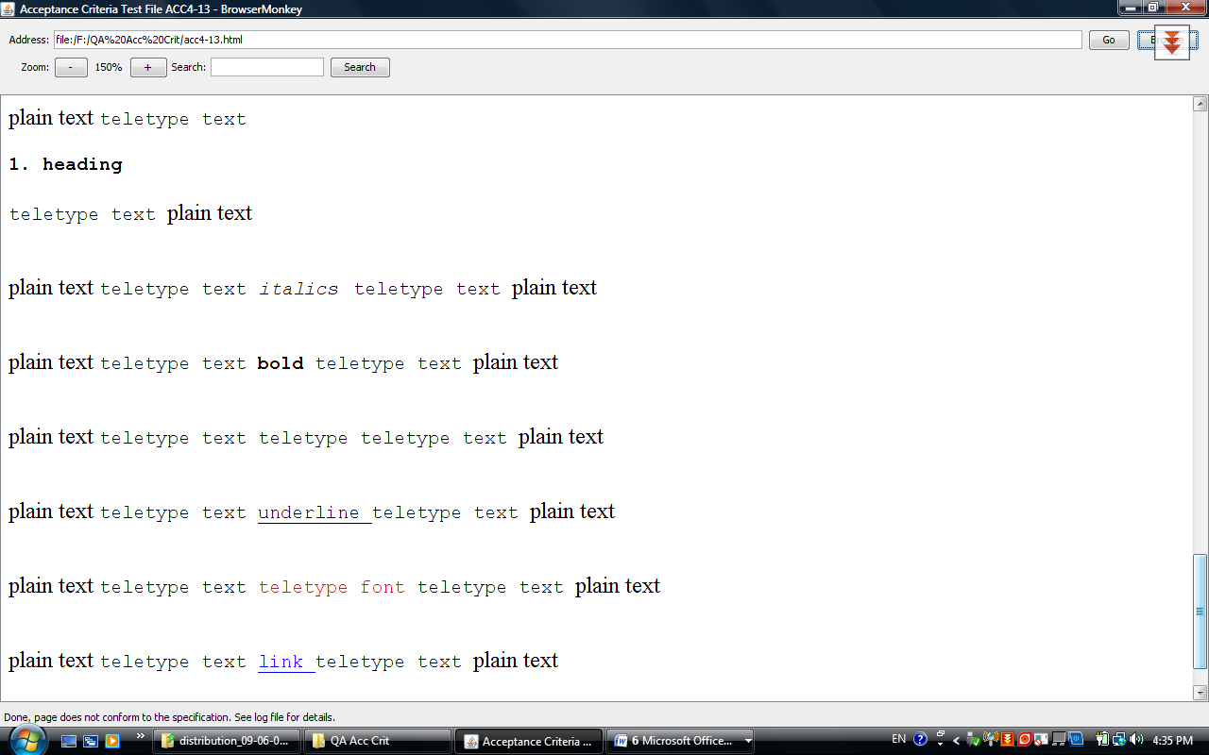

## Underline

Test passed

|  |  |  |  |  |
| --- | --- | --- | --- | --- |
| **Tests Id** | **Tested by** | **Most Recent Test** | **Pass/Fail** | **Details** |
| acc4-14-0001 | Elpida Kyriakou | 05/06/2009 | Pass |  |
| acc4-14-0002 | Elpida Kyriakou | 05/06/2009 | Pass |  |
| acc4-14-0003 | Elpida Kyriakou | 05/06/2009 | Pass |  |
| acc4-14-0004 | Elpida Kyriakou | 05/06/2009 | Pass |  |
| acc4-14-0005 | Elpida Kyriakou | 05/06/2009 | Pass |  |
| acc4-14-0006 | Elpida Kyriakou | 05/06/2009 | Pass |  |
| acc4-14-0007 | Elpida Kyriakou | 05/06/2009 | Pass |  |
| acc4-14-0008 | Elpida Kyriakou | 05/06/2009 | Pass |  |

Screenshot

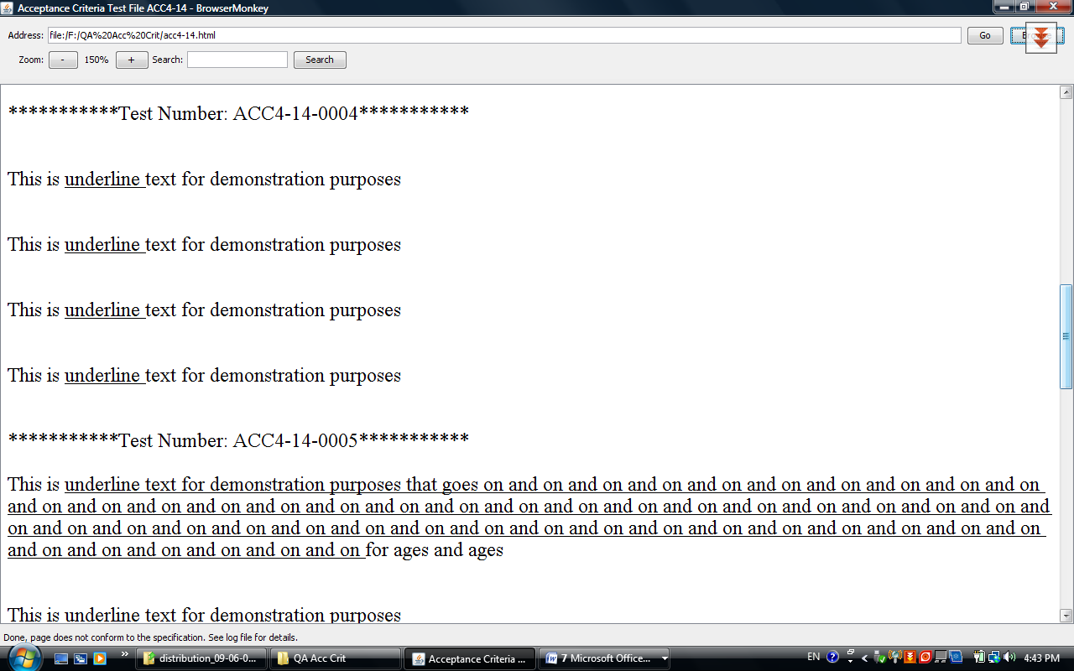

## Font

Test passed

|  |  |  |  |  |
| --- | --- | --- | --- | --- |
| **Tests Id** | **Tested by** | **Most Recent Test** | **Pass/Fail** | **Details** |
| acc4-15-0001 | Elpida Kyriakou | 05/06/2009 | Pass |  |
| acc4-15-0002 | Elpida Kyriakou | 05/06/2009 | Fail | The word “red” it should be red in all sentences. |
| acc4-15-0003 | Elpida Kyriakou | 05/06/2009 | Pass |  |
| acc4-15-0004 | Elpida Kyriakou | 05/06/2009 | Fail | Only the word red should be red in the third sentence. |
| acc4-15-0005 | Elpida Kyriakou | 05/06/2009 | Pass |  |
| acc4-15-0006 | Elpida Kyriakou | 05/06/2009 | Pass |  |
| acc4-15-0007 | Elpida Kyriakou | 05/06/2009 | Pass |  |
| acc4-15-0008 | Elpida Kyriakou | 05/06/2009 | Pass |  |
| acc4-15-0009 | Elpida Kyriakou | 05/06/2009 | Pass |  |
| acc4-15-0010 | Elpida Kyriakou | 05/06/2009 | Pass |  |
| acc4-15-0011 | Elpida Kyriakou | 05/06/2009 | Pass |  |
| acc4-15-0012 | Elpida Kyriakou | 05/06/2009 | Pass |  |
| acc4-15-0013 | Elpida Kyriakou | 05/06/2009 | Pass |  |
| acc4-15-0014 | Elpida Kyriakou | 05/06/2009 | Pass |  |
| acc4-15-0015 | Elpida Kyriakou | 05/06/2009 | Pass |  |
| acc4-15-0016 | Elpida Kyriakou | 05/06/2009 | Pass |  |

Screenshot

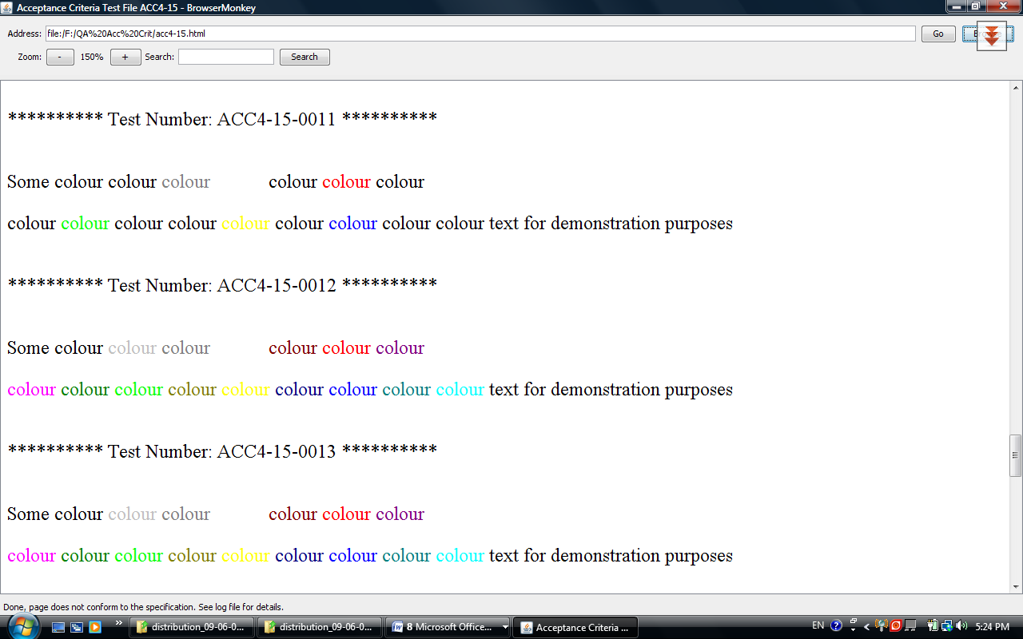

# Requirements 5 – Tables

|  |  |  |  |  |
| --- | --- | --- | --- | --- |
| **Tests Id** | **Tested by** | **Most Recent Test** | **Pass/Fail** | **Details** |
| acc5-0001 | Sohani Amiruzzaman | 5/06/2009 | Pass |  |
| acc5-0002 | Sohani Amiruzzaman | 5/06/2009 | Pass |  |
| acc5-0003 | Sohani Amiruzzaman | 5/06/2009 | Pass |  |
| acc5-0004 | Sohani Amiruzzaman | 5/06/2009 | Fail |  |
| acc5-0005 | Sohani Amiruzzaman | 5/06/2009 | Pass |  |
| acc5-0006 | Sohani Amiruzzaman | 5/06/2009 | Fail |  |
| acc5-0007 | Sohani Amiruzzaman | 5/06/2009 | Pass |  |
| acc5-0008 | Sohani Amiruzzaman | 5/06/2009 | Pass |  |
| acc5-0009 | Sohani Amiruzzaman | 5/06/2009 | Pass |  |
| acc5-0010 | Sohani Amiruzzaman | 5/06/2009 | Pass |  |

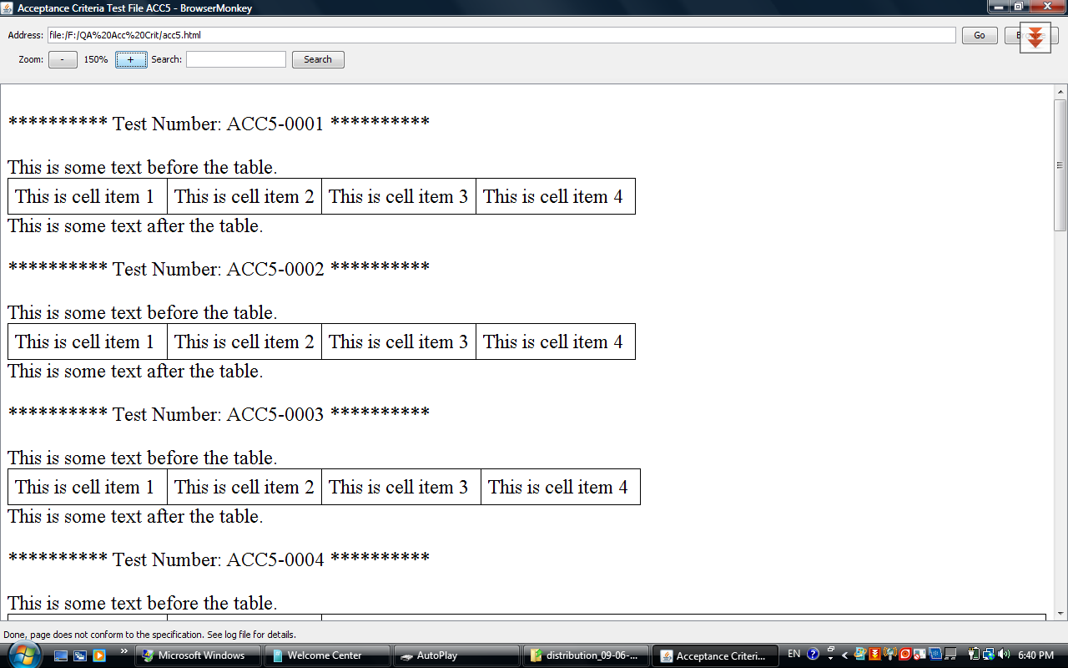

# Requirement 6 – Links

Test passed

|  |  |  |  |  |
| --- | --- | --- | --- | --- |
| **Tests Id** | **Tested by** | **Most Recent Test** | **Pass/Fail** | **Details** |
| acc6-0001 | Irene Schiza | 05/06/2009 | Pass |  |
| acc6-0002 | Irene Schiza | 05/06/2009 | Fail |  |
| acc6-0003 | Irene Schiza | 05/06/2009 | Pass |  |
| acc6-0004 | Irene Schiza | 05/06/2009 | Pass |  |
| acc6-0005 | Irene Schiza | 05/06/2009 | Pass |  |
| acc6-0006 | Irene Schiza | 05/06/2009 | Pass |  |
| acc6-0007 | Irene Schiza | 05/06/2009 | Pass |  |
| acc6-0008 | Irene Schiza | 05/06/2009 | Pass |  |

Screenshot

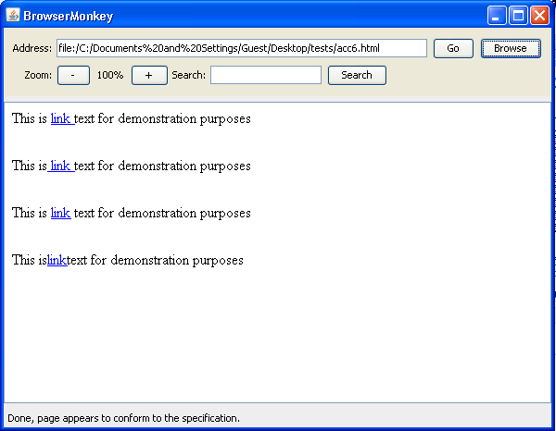

***Expected result: Log message***

INFO: Loading file:/C:/Documents%20and%20Settings/Guest/Desktop/tests/acc6-001.html

05-Jun-2009 21:43:42 browsermonkey.utility.BrowserMonkeyLogger status

INFO: Done, page appears to conform to the specification.

# Requirement 7 – Search

|  |  |  |  |  |
| --- | --- | --- | --- | --- |
| **Tests Id** | **Tested by** | **Most Recent Test** | **Pass/Fail** | **Details** |
| acc7-0001 | Ioanna Kyprianou | 05/06/2009 | Pass |  |
| acc7-0002 | Ioanna Kyprianou | 05/06/2009 | Pass |  |
| acc7-0003 | Ioanna Kyprianou | 05/06/2009 | Pass |  |
| acc7-0004 | Ioanna Kyprianou | 05/06/2009 | Pass |  |
| acc7-0005 | Ioanna Kyprianou | 05/06/2009 | Pass |  |
| acc7-0006 | Ioanna Kyprianou | 05/06/2009 | Pass |  |
| acc7-0007 | Ioanna Kyprianou | 05/06/2009 | Pass |  |
| acc7-0008 | Ioanna Kyprianou | 05/06/2009 | Pass |  |
| acc7-0009 | Ioanna Kyprianou | 05/06/2009 | Pass |  |
| acc7-00010 | Ioanna Kyprianou | 05/06/2009 | Pass |  |

Screen shots:

1. Acc7-0004

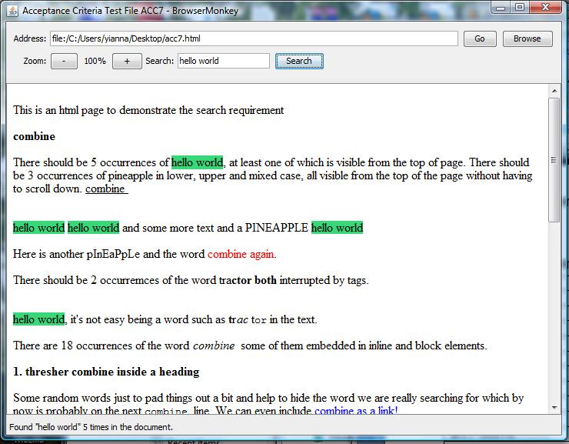

1. ACC7-0006

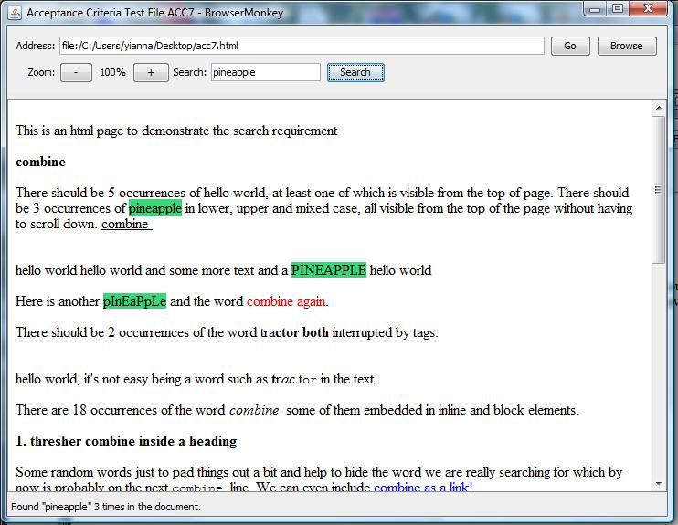

1. ACC7-0009

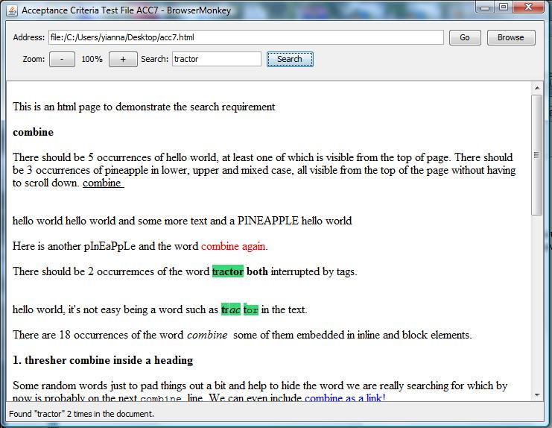

# 4.ACC7-0010 C:\Users\yianna\Desktop\screen shots fail(new)\acc7-10.jpg

# Requirement 8 – Zoom

Test passed

|  |  |  |  |  |
| --- | --- | --- | --- | --- |
| **Tests Id** | **Tested by** | **Most Recent Test** | **Pass/Fail** | **Details** |
| acc4-14-0001 | Elpida Kyriakou | 05/06/2009 | Pass |  |
| acc4-14-0002 | Elpida Kyriakou | 05/06/2009 | Pass |  |
| acc4-14-0003 | Elpida Kyriakou | 05/06/2009 | Pass |  |
| acc4-14-0004 | Elpida Kyriakou | 05/06/2009 | Pass |  |
| acc4-14-0005 | Elpida Kyriakou | 05/06/2009 | Pass |  |
| acc4-14-0006 | Elpida Kyriakou | 05/06/2009 | Pass |  |
| acc4-14-0007 | Elpida Kyriakou | 05/06/2009 | Pass |  |
| acc4-14-0008 | Elpida Kyriakou | 05/06/2009 | Pass |  |

Screenshot of a complicated html file. We use a complicate html file because the html files that we have in the acceptance criteria it is very simple.

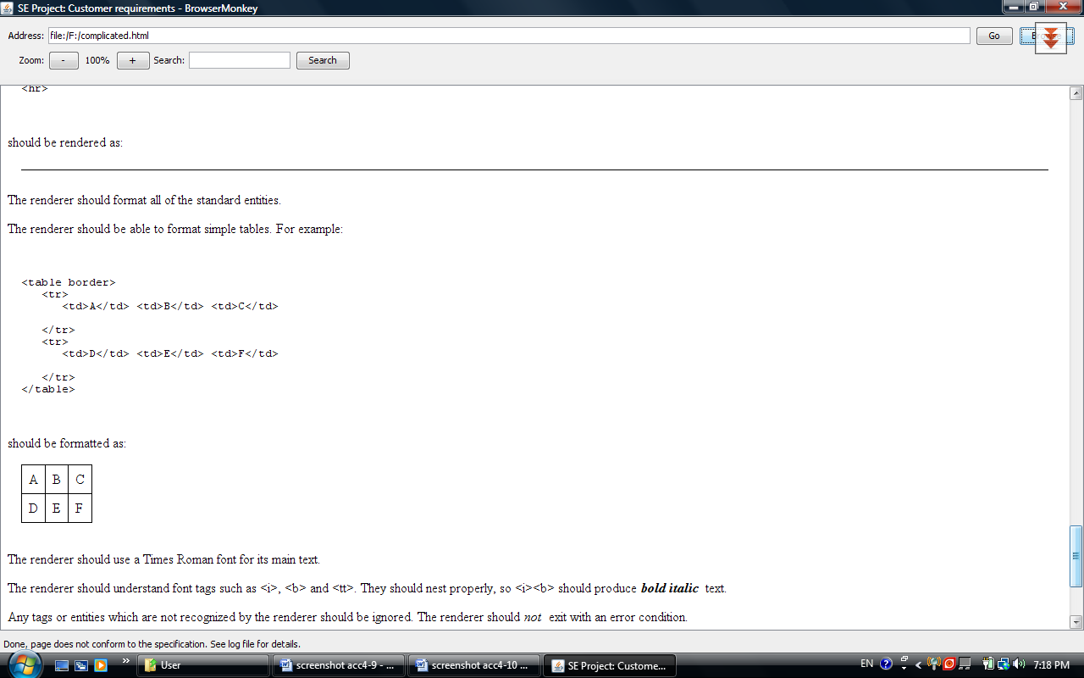

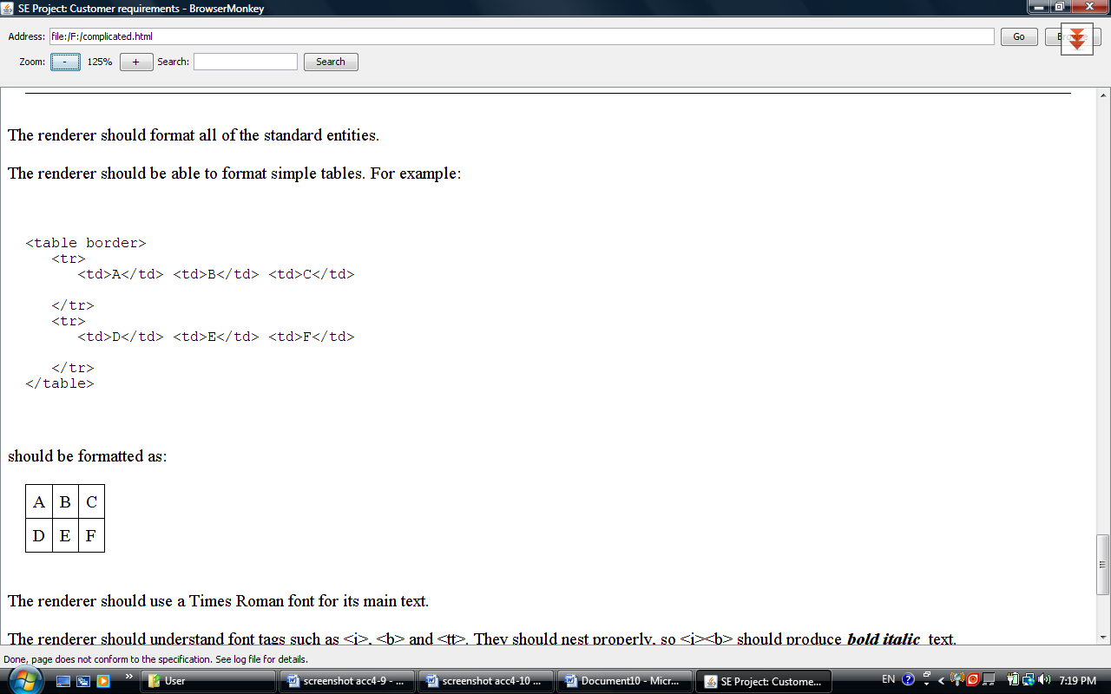

Screenshot: of the image of the home page.

